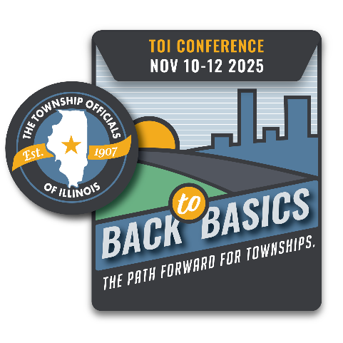
2025 Virtual Events Registration

May 28 9:00 am – 2:00 pm

June 17 9:00 am – 2:00 pm

Agenda
10:00 AM Program Introduction
Pledge of Allegiance
Opening Comments, Craig Paulek, TOI President
Welcome, Jerry B. Crabtree, TOI Executive Director
Comments, Jim Donelan, TOIRMA Executive Director
10:30 AM Budget and Levy
11:30 AM Lunch
12:00 PM Freedom of Information Act/Open Meetings Act
1:00 PM Building a Meeting Agenda
2:00 PM Adjourn
County Township
Address City State Zip
Names & Email of those who will attend (please print clearly):
Supervisor: Township Clerk: Highway Comm.: Assessor: Trustee: Trustee: Trustee: Trustee: Collector: Other/title:
Registration is $25 per person.
*Please make checks payable to the Township Officials of Illinois; mail to 3217 Northfield Drive., Springfield, IL 62702. Forms may also be emailed to teresa@toi.org. If you are paying by credit card, only Visa and MasterCard are accepted:

Name, as it appears on card: Credit Card Number Exp.:

